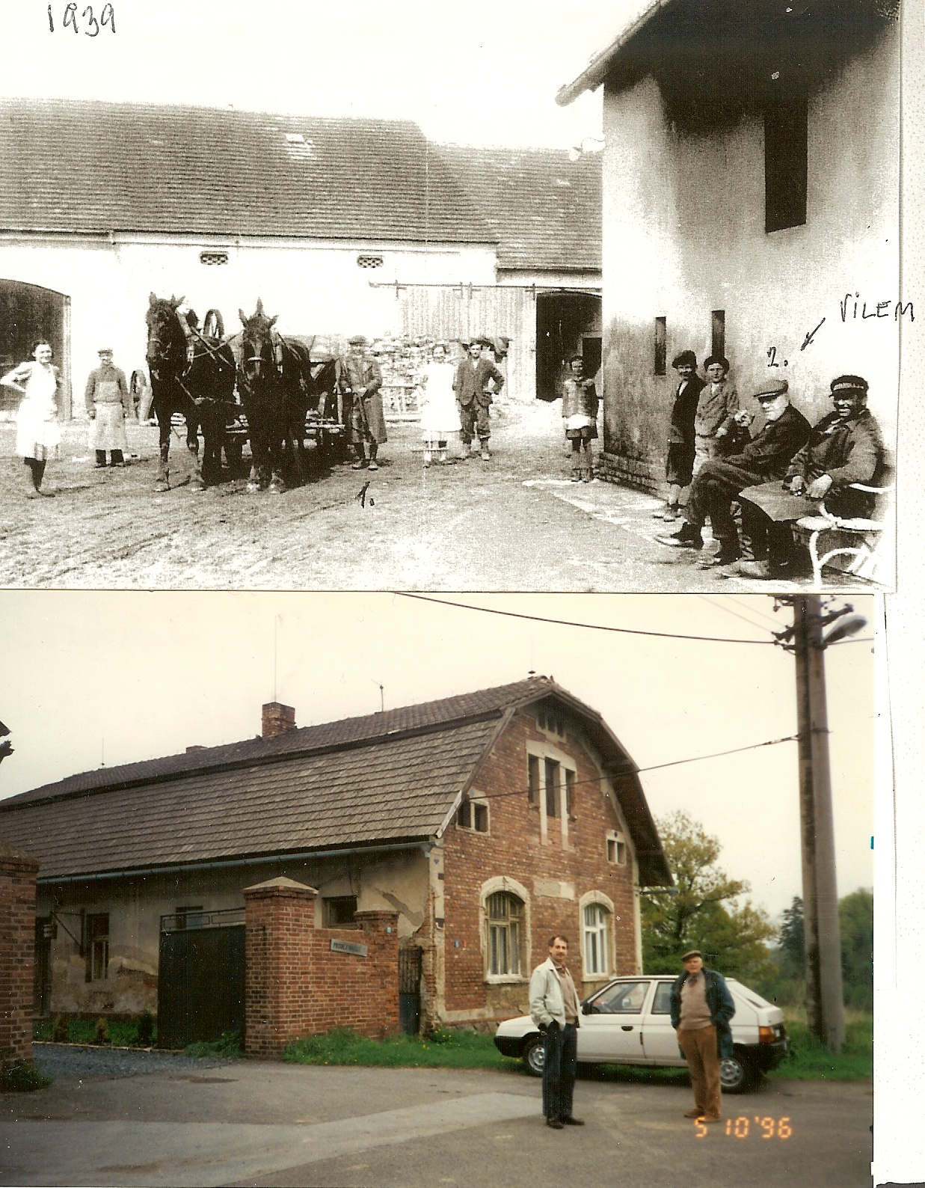

Karel Bejkovsky-my guide.